STEP BY STEP REGISTRATION FOR MINDFUL SCHOOLS COURSES

Once you have received approval from your Regional Inclusive Schooling Coordinator to use their funding code:

1. Go to: http://www.mindfulschools.org/

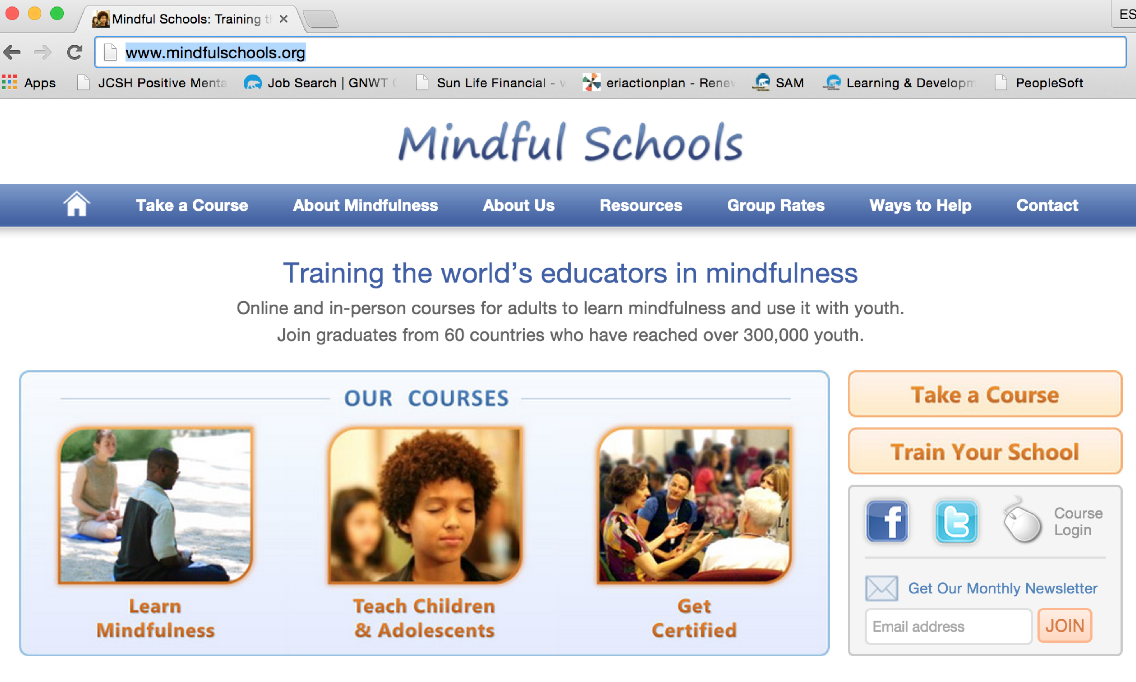

2. Click on Take a Course – on right of screen (or at the top of the bar)

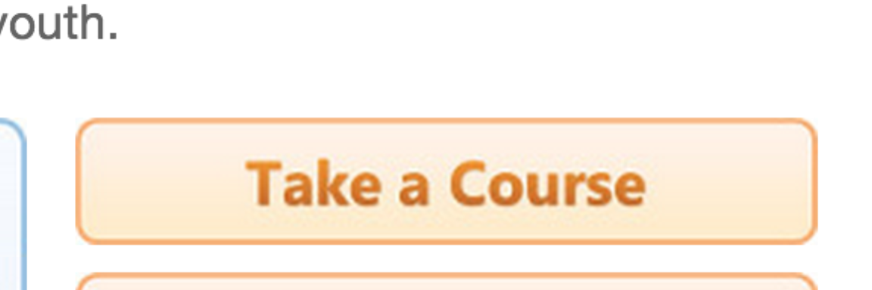

3. Select your course & click on it.

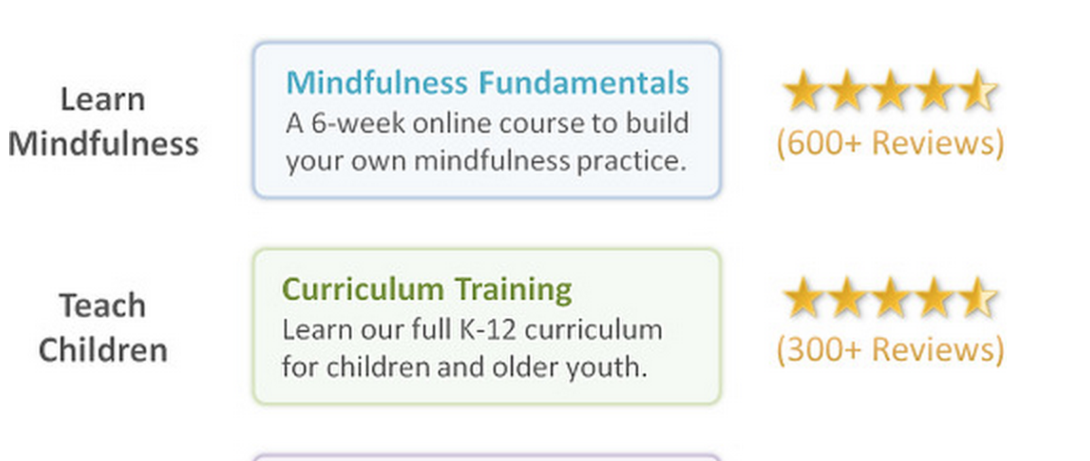

4. Pick the dates and select enroll.

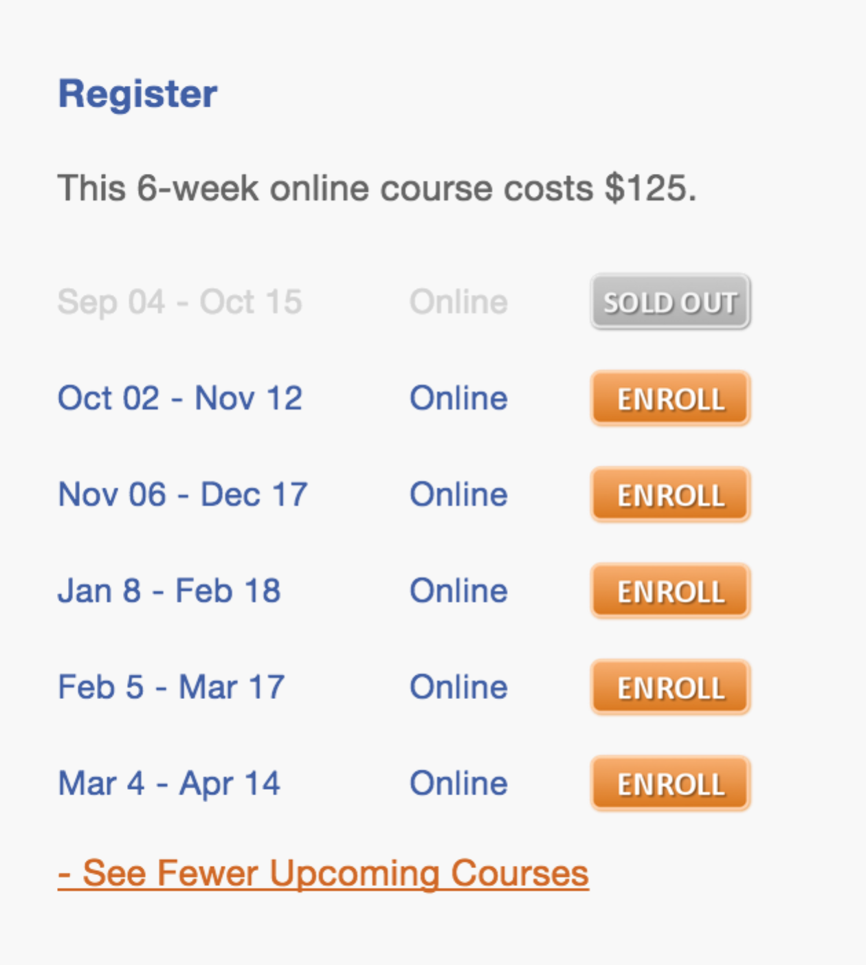

5. Enter your email address twice. Put your region code in the GROUP DISCOUNT CODE box.

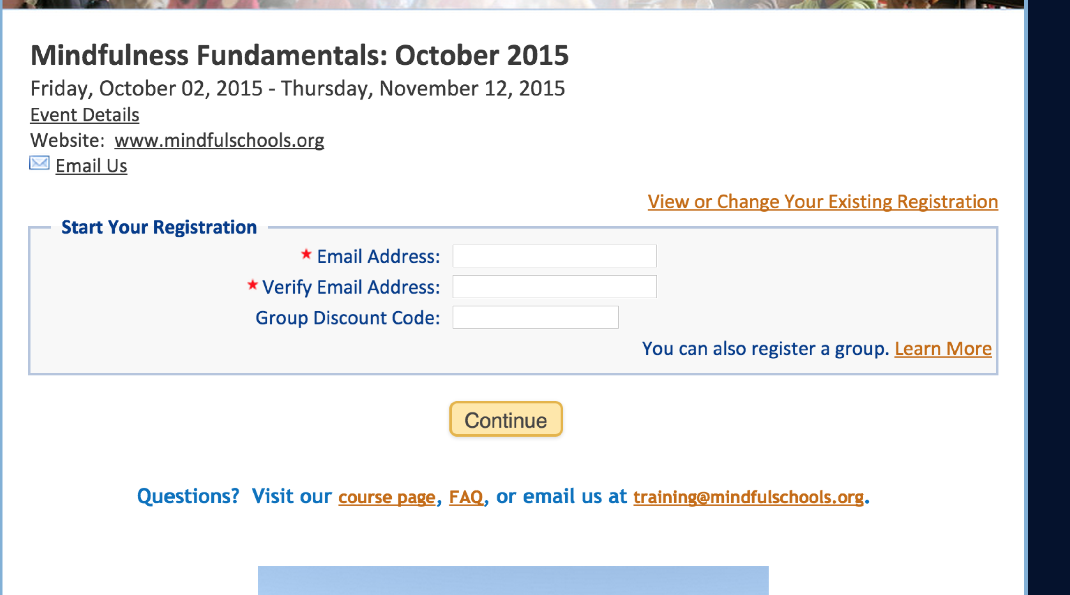

6. From the payment options enter PURCHASE ORDER. Leave the box blank.

Voila you are done! You will receive a confirmation email.

