STATION ONE

5 jumping jacks
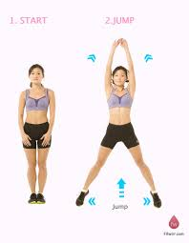
5 palms to floor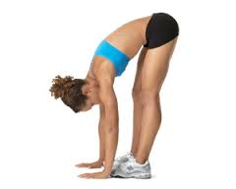

5 elbow to knee

STATION TWO

10 jumps on the trampoline

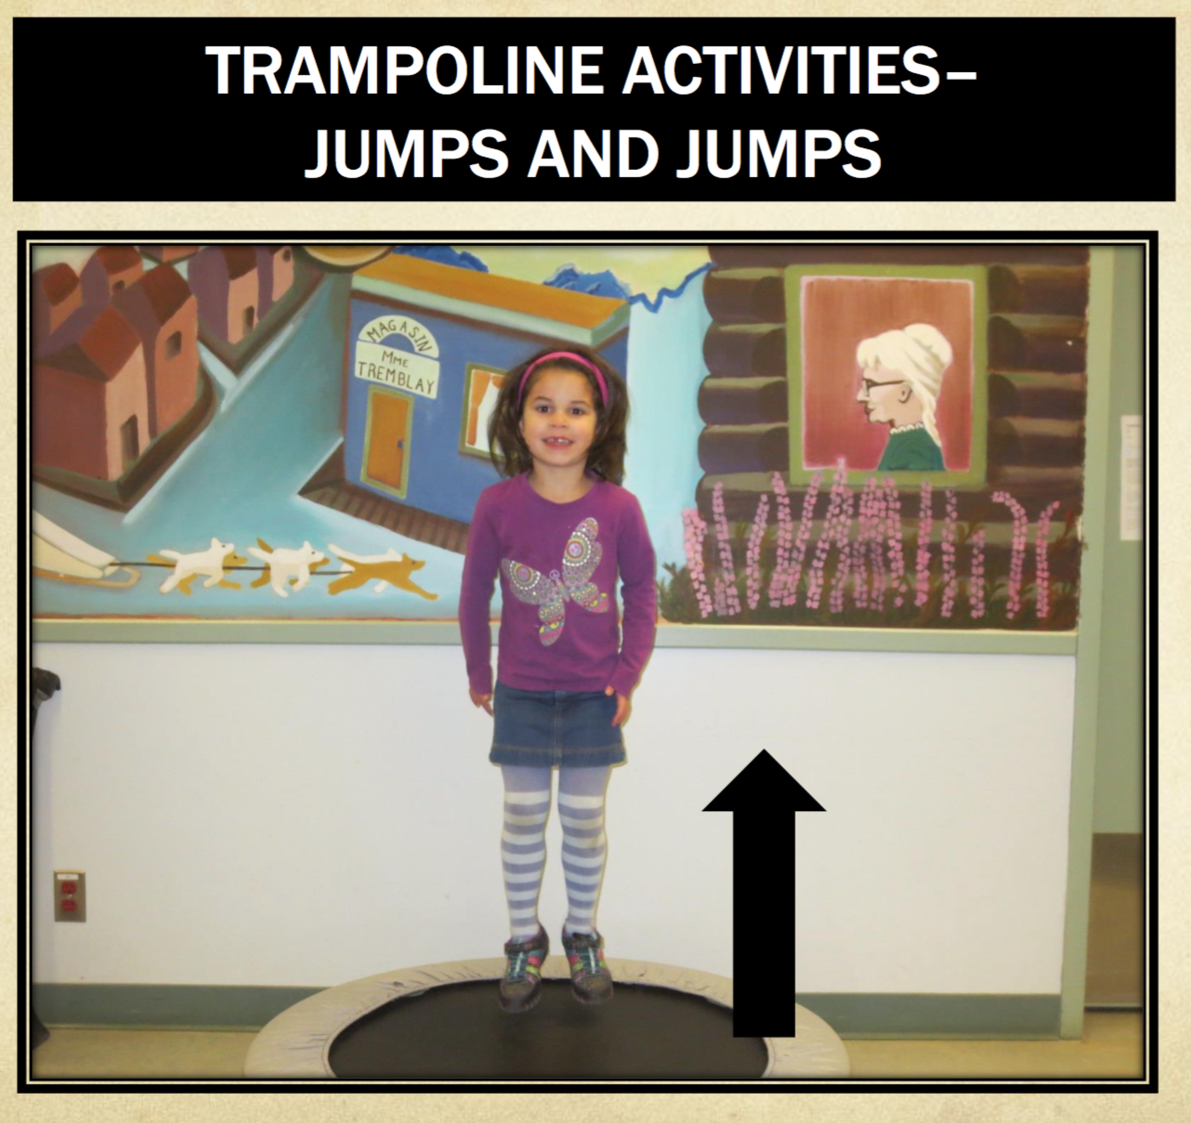

STATION THREE

Theraband stretches on the Yoga ball

10 in front
10 diagonal
10 behind

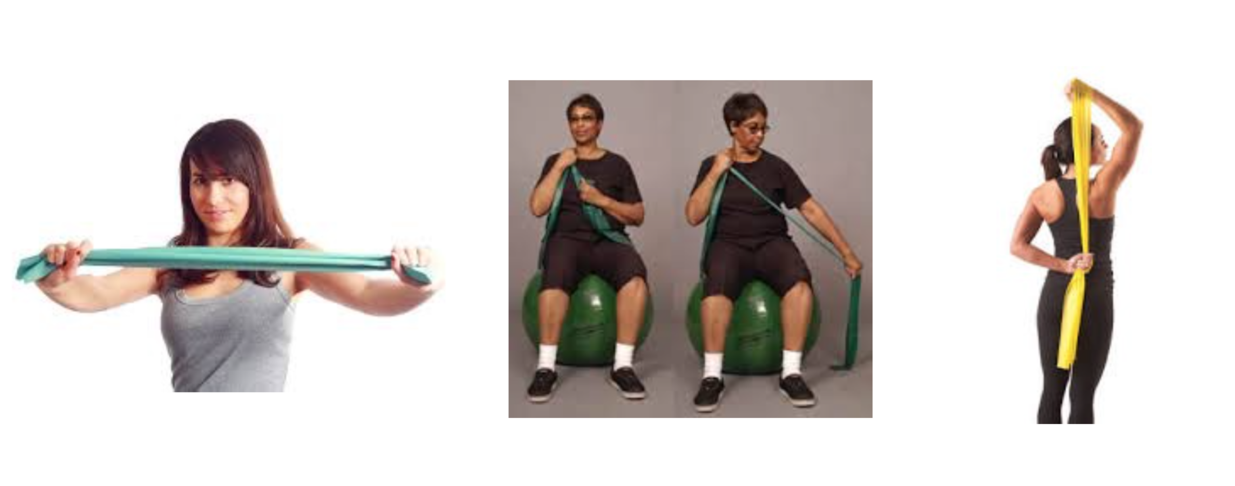

STATION FOUR

5 wall push ups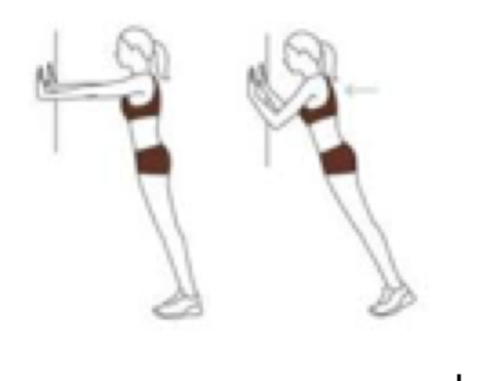
5 crab walks
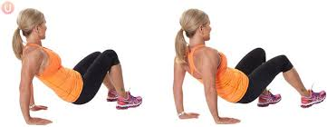

5 hand to knee w/ weighted wrist band

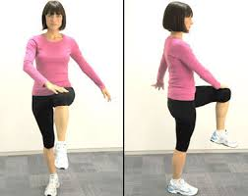

STATION FIVE

5 back & forth stomach /yoga ball walks to jigsaw puzzle
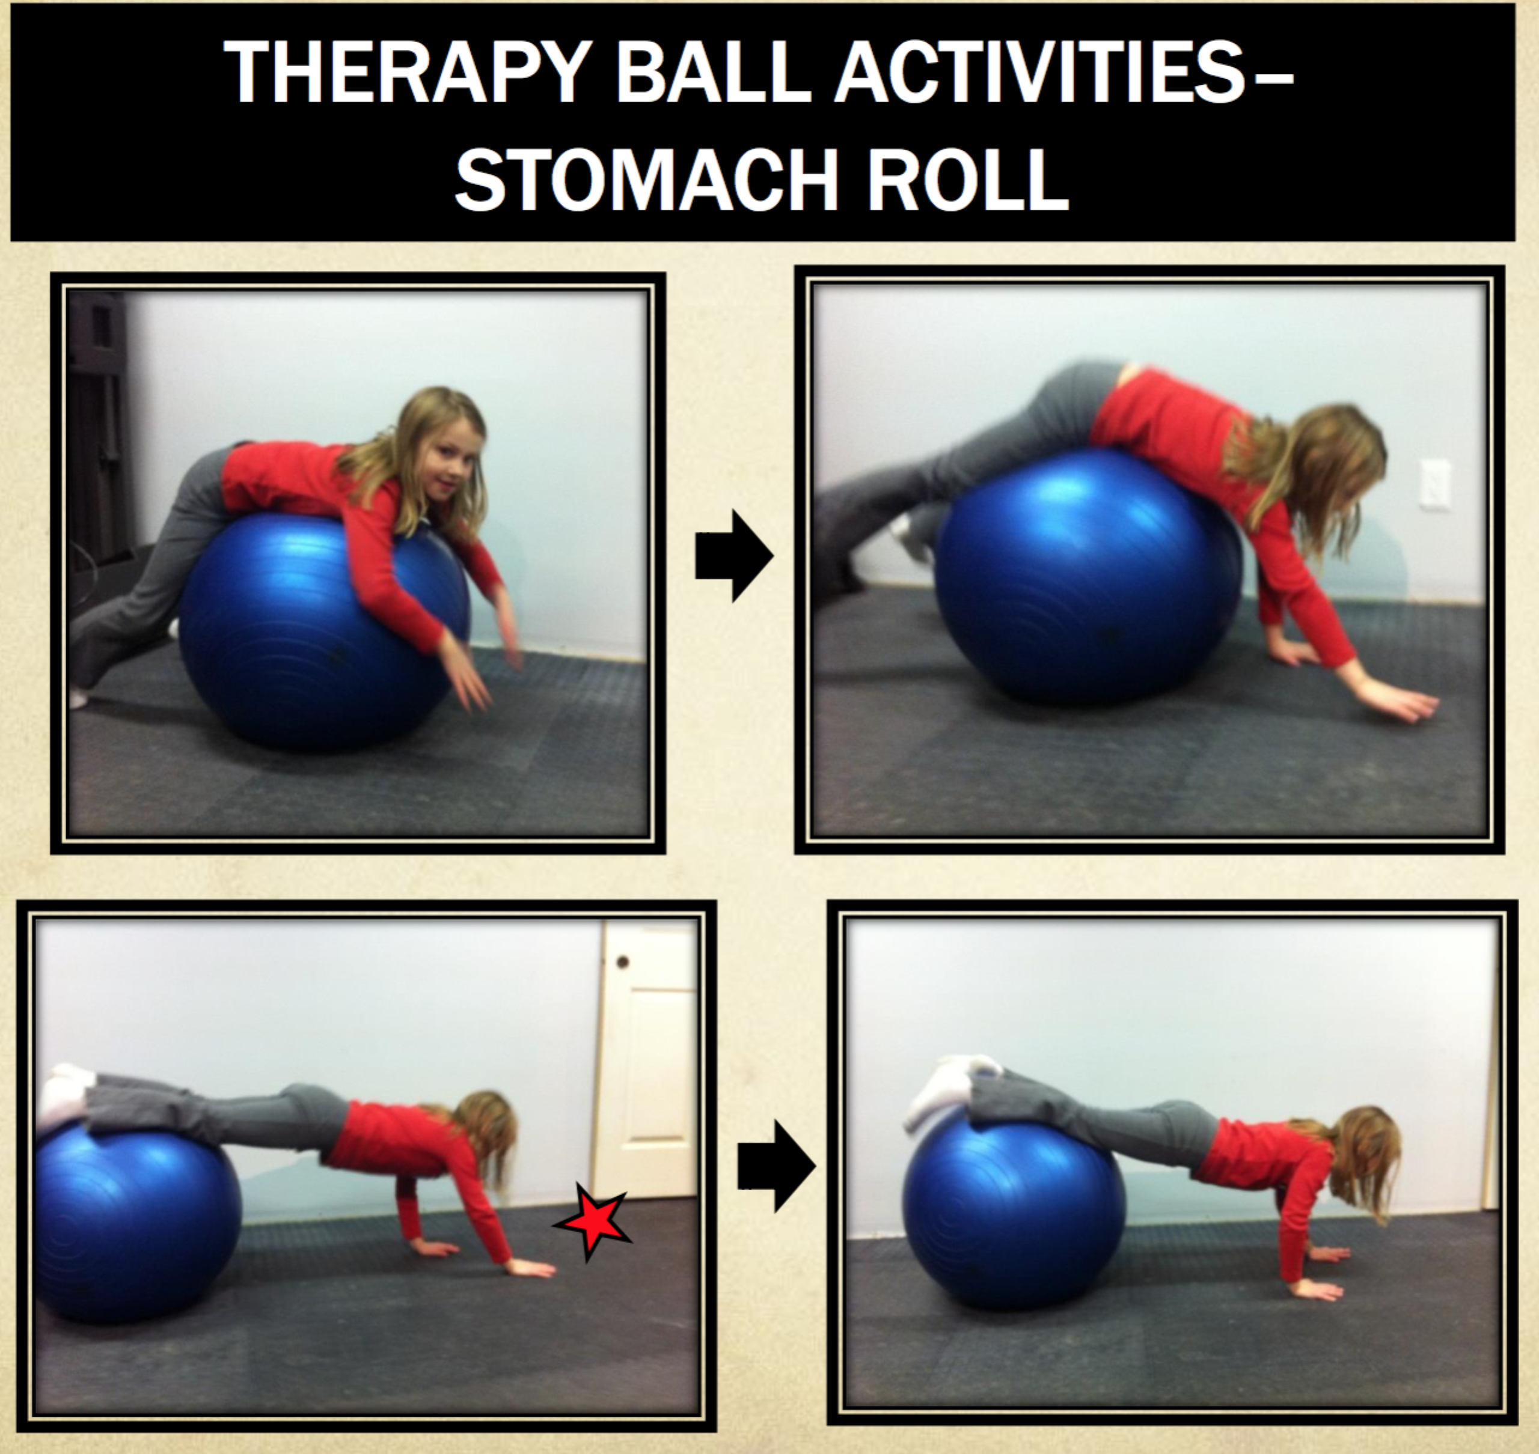
STATION SIX

10 alternating one-footed stands on half yoga ball
or balance seesaw

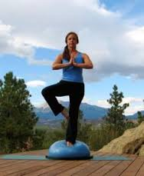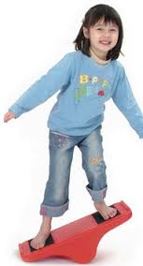

STATION SEVEN

Cotton ball blow with straw across the line
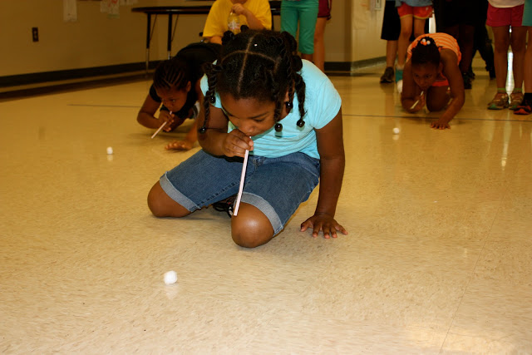

Deep breathing
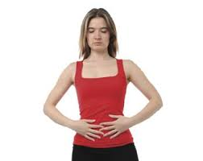

Listening to music

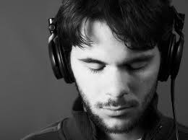

Yoga poses (downward dog, warrior, cat/cow, child’s pose)

